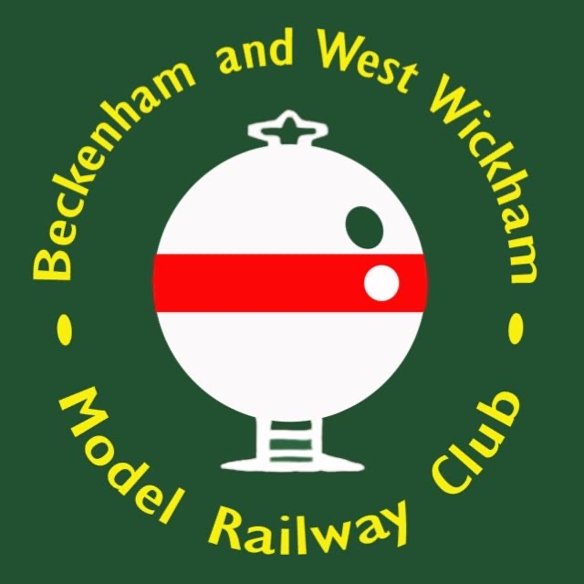
Beckenham and West Wickham
Model Railway Club

VINTAGE MODEL RAILWAY SHOW 2024

Forest Hill Boys School

Dacres Road – Forest Hill – London – SE23 2XN

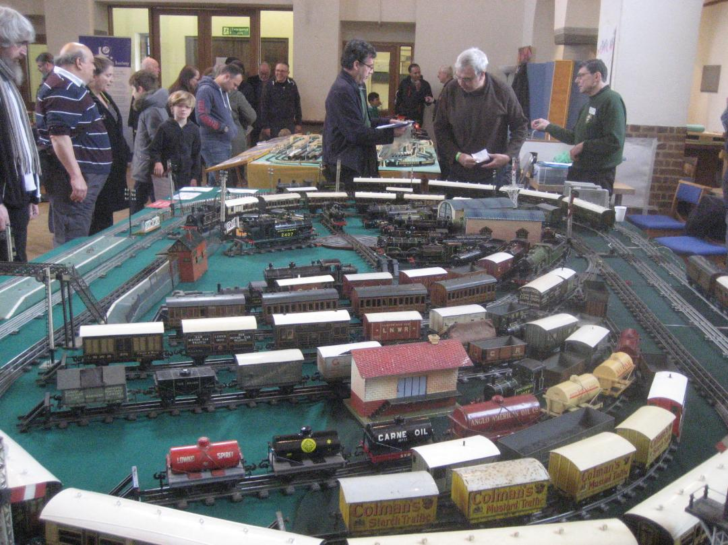
G S MARSHALL ©
Saturday 23rd March 2024
Supported By:
Hornby Railway Collectors Association (HRCA)
Train Collectors Society (TCS).
Bassett-Lowke Society.
Sussex Vintage Model Railway Collectors

Beckenham and West Wickham
Model Railway Club

WELCOME TO OUR VINTAGE MODEL RAILWAY SHOW 2024

The Club’s bi-annual exhibition at our NEW location here at Forest Hill Boys School is a major event in the club’s programme, and you are very welcome whether you are a regular attendee or a new visitor. Our Exhibition Manager has put together a selection of layouts and stands to provide something of interest whether you are involved in the vintage model railway hobby or a member of the public. We welcome you to our new venue with more space and better transport links for you all and amazing food area with homemade cakes…. Yum!

Although B&WWMRC does not normally run vintage trains, if you find your visit to the exhibition has sparked a latent interest in scale model railways, please ask one of the exhibition stewards for details of the club and come along one evening to find out more.

B&WWMRC

The success of an event such as this requires a huge amount work by the club members, I personally would like to take this opportunity to thank them on your behalf for their hard work not just over the period of this weekend but throughout the year in preparing the home layouts on show and the other matters of general administration.

You may wish to look at the plan on the centre pages to help guide you around the hall. We welcome your views, so please track me down. Enjoy the show!

Tony Penn
Vice-Chairman & Exhibition Manager B&WWMRC
The Beckenham and West Wickham
Model Railway Club
NEW MEMBERS WANTED!

BACK PAGE FOR DETAILS
Or visit www.bwwmrc.co.uk

Stand 1 - Bob Leggett Second Hand Sales. Specialising in Vintage Triang and other 00 Gauge makes. bobleggett@btinternet.com

Stand 2 - Vintage N Gauge by Peter Ingleton.
It comes as a shock to many that N-Gauge has been available since the 1960’s and Peter specialises in running these early trains which pre-date some of the more common vintage makes.

Stand 3 - Cyril Kennett Second Hand Sales Specialising in Vintage 0 Gauge.
janetandcyril@gmail.com

Stand 4 - Triang Series 3 by Paul Lester
In 1950, Rovex Plastics Limited, of Richmond, Surrey, produced a range of model trains exclusively for Marks and Spencer using plastic (cellulose acetate) moulded bodies. Rovex Plastics Limited was taken over by Lines Bros in 1951 and the range was launched as Tri-ang Railways in 1952. In 1964 with the takeover of Meccano Ltd, the manufacturers of Hornby Dublo trains, Lines Bros then merged their own Tri-ang Railways and the Meccano Hornby range and it was renamed Tri-ang Hornby.
Paul is running Triang Trains from the late 1950s and early 60s era.

Stand 5 - Kitmaster Collectors Club. Second Hand Sales specialising in Kitmaster and other plastic kits from the early 1960s kitmasterbloke@gmail.com

SAVE THE DATE
Beckenham Vintage
Model Railway Show
SATURDAY 5th APRIL 2025

Stand 6 - Four Feather Falls, a Lone Star TrebloLectric by Stephen Searson.

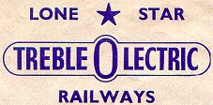
The parent company of "Lone Star" was the Die Casting Machine Tools Ltd. of Palmers Green, London, N13, and it was established in 1939. They were among the world's leading manufacturers of die cast metal model cap-firing guns, and model vehicles – road, rail, and air. The range of Western-style pistols and rifles was first introduced in 1949. In 1960, Lone Star Products Ltd. entered the die cast metal car market and, ten years later, their range comprised over 70 different models, the series of which were continually added to until 1988 when the company was sold. The railway side started in 1957 with a push-along half OO size range of models copied from the OO ranges of Tri-ang and Hornby-Dublo, hence OOO, then in 1960 the electric range came along, this range duly expanded to have more American items as this ended up as the main market.

This then was the first commercially produced OOO (N) Gauge system, powered using a novel rubber band drive from the electric motor, the last new products for America were added in 1964. A year later the range was in trouble mainly from the slot car revolution and the new German N Gauge models coming to the market place and the range was for sale. With no takers production fizzled out with some models from the electric range rebranded into another push along range which was sold through Woolworths and others for a few more years, so ended the “First OOO Model Electric Railway” (a selling slogan).
I have used the Lone Star Treble OOO products in the build of this layout with some others that were available at the time, the back scene is Builteezi reduced to N gauge size and some extra Matchbox vehicles. I have also added some neverwasers to the setup such as, the planed Loading gauge and NBL Warship diesel not made, and a track cleaning wagon, based upon the Hornby Dublo rarity.

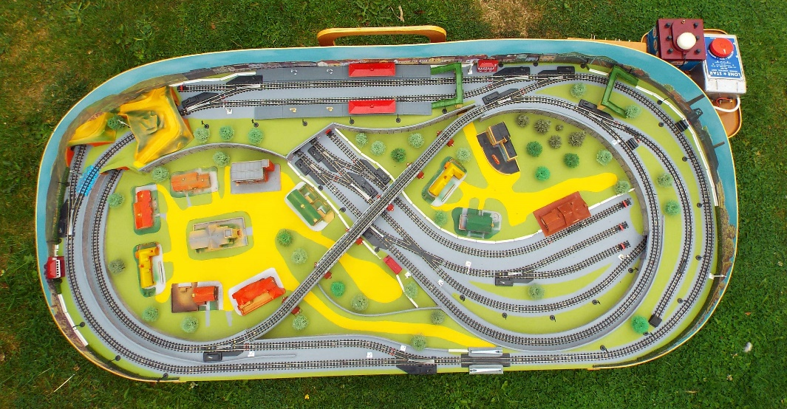

Stand 7 – W J Vintage 0 Gauge Modle Railways.
Established in October 2011, WJVintage is a, small, friendly business created and run by enthusiasts with a passion for traditional, coarse scale, ‘O’ Gauge Model Railways. Our goal is to become a ‘one-stop’ shop for all of your traditional ‘O’ Gauge requirements in ‘ready to run’ model form. wjvintage@outlook.com www.wjvintage.co.uk
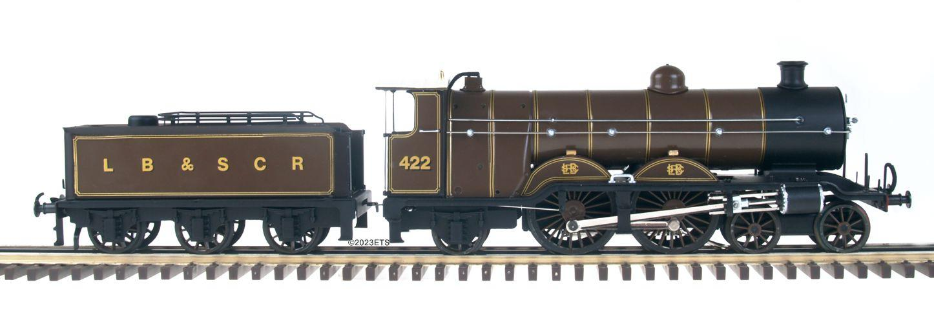
Stand 8 - Kitorama
Neil Jackson, a demonstration of plastic kit building techniques.
Stand 9 - Bassett-Lowke layout by the Bassett-Lowke Society.
The Bassett-Lowke society caters for those interested in the products of Bassett-Lowke Ltd, in particular model railway equipment, but also including model ships and other model engineering items. The society also welcomes those interested in the other model railway and model engineering makes of the same period, such as Bing, Carette, Mills, Leeds, Bonds 'o Euston Road, Douglass, Exley, CCW etc.
http://www.bassettlowkesociety.org.uk/

Stand 10 - Hornby 0 Gauge by Adam Heeley (HRCA)
Frank Hornby's company Meccano Ltd started making model railways shortly after the end of the First World War. Prior to WW1 most trains sold in the UK were of German Manufacture. Hornby continued to produce 0 Gauge Trains up until the demise of Meccano Ltd in 1964. If you are interested in Vintage Hornby then the Hornby Railway Collectors Assoc which has Area Groups around the country is a good bet.
https://www.hrca.net/

List of Stands

Stand 1 - Bob Leggett
Stand 2 - Vintage N Gauge
Stand 3 - Cyril Kennett
Stand 4 - Triang Series 3
Stand 5 - Kitmaster
Stand 6 - TrebloLectric
Stand 7 – W J Vintage
Stand 8 - Kitorama
Stand 9 - Bassett Lowke
Stand 10 - Hornby 0 Gauge
Stand 11 - Battlespace
Stand 12 - Colin Penn
Stand 13 - Lego
Stand 14 - Cafeteria
Stand 15 - Elaine’s Trains
Stand 16 - WM Collectibles
Stand 17 - Marklin 0 Gauge
Stand 18 - Hornby M Series
Stand 19 - Wrenn
Stand 20 - DOGA
Stand 21 - BWWMRC Club Shop
Stand 22 - Club N Gauge
Stand 23 - Dublo 3 Rail
Stand 24 - Minic Motorway
Stand 25 - Seating Area
Stand 26 - British Cheap and Cheerful (0 Gauge)
Stand 27 - Andy Lynch
Stand 28 - Dublo 3 Rail I’Ad That

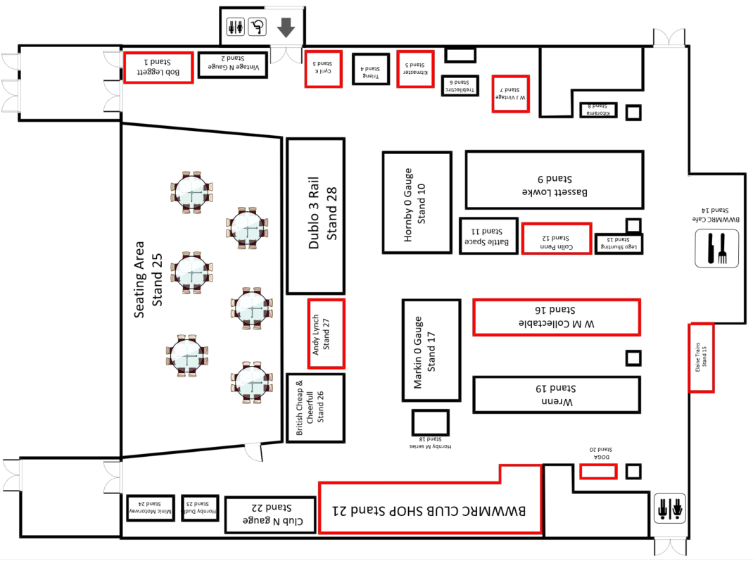

Stand 11 - Battlepsace Tony and Terry Penn
And Sussex Vintage MRC.
Triang trains always had greater play value than other makes. The Battlespace Range from the 1960s and 70s had missile launchers, cap firing bombs, exploding wagons, flying helicopters and aeroplanes. Consequently a lot got damage and thrown away making the survivors very precious indeed.

Sussex Vintage MRC present their 'all Action'

Vintage Model Railway Show
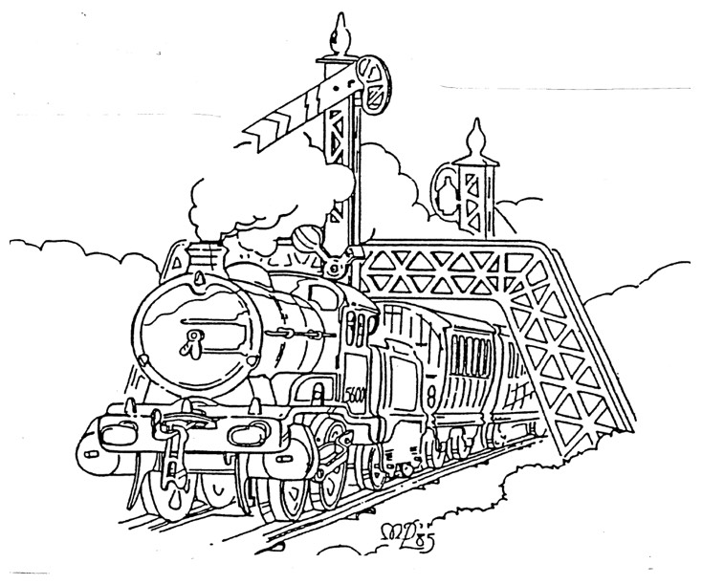
Join us on the 6th of July 2024 10:00 to 16:30 or our model railway show. We'll have huge displays of rare operating layouts & displays and Collectors Trade Tables. Refreshments will be available all day in the 'Buffet Car'. Plumpton Village Hall is within 1/2 a mile of Plumpton BR station. There is also free parking on site and disabled access. Adults: £5.00 Family Ticket (2+2): £8.00 Accompanied Children (under 16): Free. Plumpton Village Hall, 1 West Gate, Plumpton Green, Lewes, BN7 3BQ
https://www.sussexvintage.co.uk/
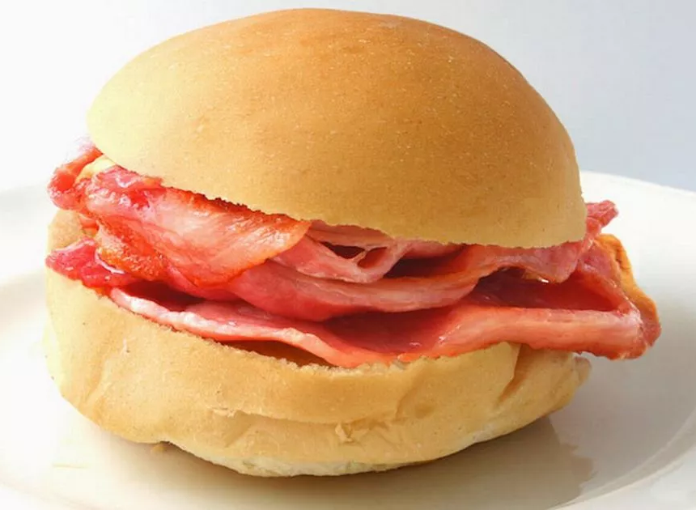
Bacon Roll £3.00
& Lots more to choose from…

Stand 12 - Colin Penn Second Hand Sales of all makes and gauges.
motorail3@virginmedia.com

Stand 13 - Lego Southern Railway UK by Levi
Lego trains were first introduced in 1966. The first train sets were simply push-along. Set number 115 introduced 4.5v battery-operated trains. 12v electrified trains were introduced in 1969. Lego continue to manufacture trains.

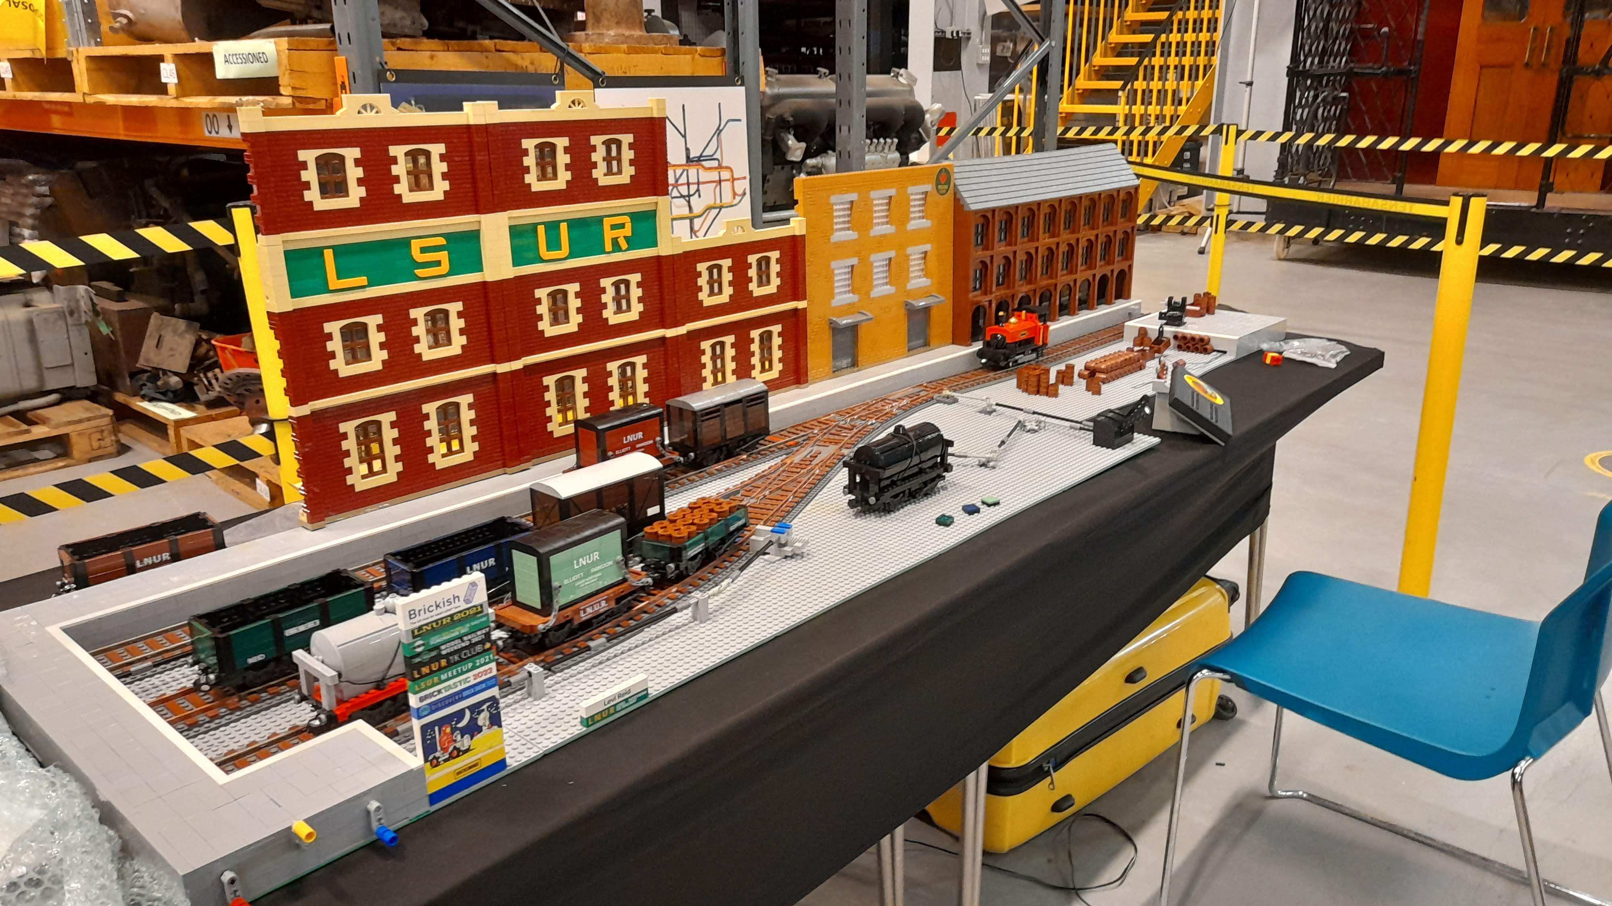
The layout is fully controlled by the members of public, (with guidance from me, of course!).

Stand 14 - Cafeteria
Light refreshments available for drinks, homemade cake, hot food, chocolate bars, crisps & more!

Stand 15 - Elaine’s Trains Second Hand Sales.
At Elaine's Trains we specialise in pre-owned model railway items particularly Tri-ang and Hornby and Continental HO
elaine@elaines-trains.co.uk Phone 01673 857 423 (Landline). Postal and Exhibition Sales only, no retail premises.

SAVE THE DATE

SATURDAY 19th OCTOBER 2024
Scale Model Railway Show

Stand 16 – W. M. Collectables
We sell quality collectable and pre-owned model railway items in most gauges. I specialise in Triang OO and TT but also have a good selection of other makes including Wrenn, Hornby, Hornby Dublo,Trix, Lima, Mainlline, Bachmnn, Airfix and Lone Star. Phone 01444 413 723 andrew@wmcollectables.co.uk

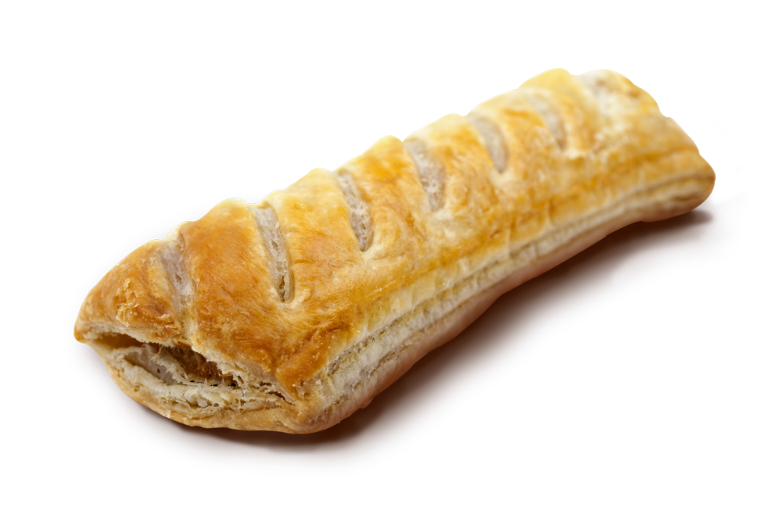
Hot Sausage Roll £2.00 Tea/coffee £1.50
Stand 17 - Marklin 0 Gauge by Mark Carne, Michael Parkes and Tim Walker (HRCA and TCS)
Märklin in the 1890s produced everything from enamelled toy fountains to scientific equipment, but their main achievement is the introduction of the concept of standardised gauges for model railways. Märklin recognised that if one was to build railway sets, it wasn't sensible to make new sets of track to go with each arbitrary-sized model train ... track had to be standardised, with subsequent trains designed to fit the existing track, rather than the track being designed to fit the trains.
Märklin’s trains in 1891 became Gauge I, joined by larger and progressively larger-numbered track gauges, gauge II and III, followed in about 1900 by a smaller gauge, gauge 0. These standard gauges promoted interoperability between different companies' products, and reduced the risk both for buyers purchasing a model railway and for third-party companies supplying specialised accessories and components.
Märklin discontinued Gauge 2 and 3 in the early 1920s continuing 0 and 1 and launched their H0 range in 1935, Marklin's 1:220 Z gauge system appeared in 1972.
https://traincollector.co.uk/
Stand 18 -Hornby M series by Harry Saunderson. (HRCA)
The Hornby M Series range of printed tinplate trains and accessories first appeared in the Hornby Book of Trains in the 1926 version of the catalogue.
These were beginner sets aimed at smaller children - on some the clockwork locomotive's key was permanently fixed to the loco so that it couldn't be lost.
It is great fun watching modern kids trying to understand how clockwork trains work !
https://www.hrca.net/
Stand 19 - Wrenn 00 Gauge by the Chiltern Hills Group of the HRCA.
After Lines Bros bought the Hornby Dublo range when Meccano Ltd went under in 1964 they sold most of the range to G R Wrenn Ltd who continued production for many years.
The HRCa has numerous Area Groups around the country, details can be found on the HRCA website. https://www.hrca.net/extra/events-public the next Chiltern Hills Group meet is on the 16th of May in C
Stand 20 - Double O gauge Association
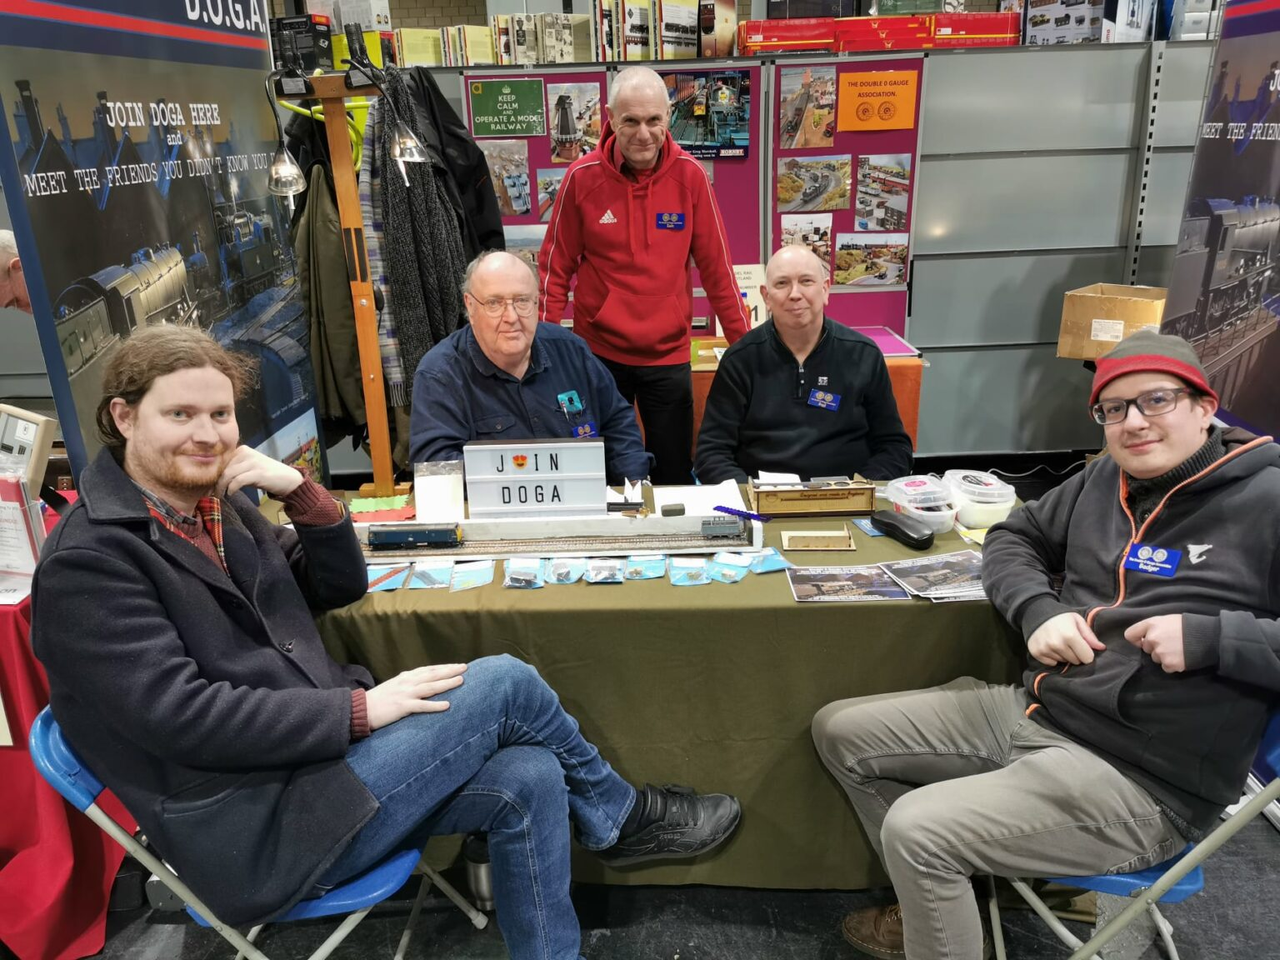
The Double O Gauge Association is an organisation which caters for both new & veteran railway modellers. As well as our quarterly magazine, joining DOGA gives you access to a member-only e-mail discussion forum to get support, advice, experience and knowledge.
Website
www.doubleogauge.com
E-mail membershipsec@doubleogauge.com

Light Refreshments Available from Drinks, Homemade cake, Hot food, Chocolate bars, Crisps & More!

Stand 21 - B&WWMRC Club Shop
Wanted your surplus Model Railways. We offer a no obligation valuation. Something for everyone.
http://www.bwwmrc.co.uk/oldtrains.shtml
Stand 22 - Heathcote The B&WWMRC’s new N Gauge Layout.
Don’t be shy our operators are only too delighted to talk about our layouts.
http://www.bwwmrc.co.uk/membership.shtml

Stand 23 - Hornby Dublo 3 Rail by Martin Wood (HRCA)
Hornby Dublo was produced by Meccano Ltd of Liverpool from 1938 to the demise of the company in 1964. The original system as used on Martin’s layout was 3 rail. A complex 2 rail system was launchened in 1959 but it was costly and difficult to run and was a large part of the reason Meccano Ltd went under….
https://www.hrca.net/

Stand 24 - Minic Motorway by David Lyon
The system was to an extent in competition with Scalextric and other slot car systems, and Minic Motorways was always fighting to retain its corner of the market. Sadly the inevitable happened, and Minic eventually went out of production in the early 1970’s.

This award winning* Minic Motorways layout is the result of over 50 years enthusiastic collecting by Dave Lyon, and aims to show the wide variety of vehicles and accessories that were available in the heyday of Minic Motorways, and its compatibility with Triang Railways.

Dave’s larger layout first appeared on the exhibition circuit in May 1996. Since then it has been to over 150 shows, including three appearances at Warley. This smaller layout was developed especially for one day shows, but still incorporated several features of its larger counterpart, including automated level crossings and crossroads.
* Winner of The Manston Locomotive Preservation Society Terry Mann Memorial Shield, Broadstairs, Nov 2004.
Winner of the Best General Model Award, Medway Model Railway Show, Chatham, Sep 2007.

Stand 25 - Seating Area.
Where you can relax and eat your food from the Cafeteria.

Stand 26 - British Cheap and Cheerful 0 Gauge by Bryan Pentland (TCS)
There have been numerous low-cost ranges of toy trains made in the UK. Colourfull and highly entertaining, but these are ‘Woolworths’ toys. Often played with a short while on the floor, brodden on, broken, and put in the bin by Mum… Once again survivors in good condition are not easy to find. https://traincollector.co.uk/

Stand 27 - Andy Lynch Second-hand Sales
Lots of lovely pre-owned model railway items across all the gauges to tempt you to add your model railway collections. We buy in your loved collection too.
Phone - 07944 212902 / 01634 573326

Stand 28 - I ‘ad That Hornby Dublo Three Rail by the Miller Bros
This renowned layout combines Dublo with scenery and intense operation. Launched in 1938 as the perfect table railway, I ‘ad that is a homage to the Hornby Dublo three rail system, which ceased production in 1964. We have created a scenic layout that incorporates many original accessories and is sympathetic to the original designs, with some modern tweaks. You may still have a three rail train set stored away in your loft. Or you may just recall… “I ‘ad that!” Fully scenic, illuminated layout
Please be aware that we regard the layout as a train set and not a model railway, therefore the following rules apply:-
- No scale speed – if trains are running slowly, it means we’ve had too many derailments
- No timetables
- No rivet counting.
- No bells
- We run whatever stock combinations we like!
https://iadthat.wordpress.com/
Light Refreshments Available from Drinks, Homemade cake, Hot food, Chocolate bars, Crisps & More!

Beckenham and West Wickham
Model Railway Club

Are you interested in model railways or transport?
Do need some advice or want to learn more?
If so, then why not join us?
If you would like to find out more, please contact the membership secretary, Philip Godfrey. You can arrange to attend some meetings to see for yourself what we do and meet some of our members - you should find some interesting people to discuss trains with. Members come from all backgrounds from accountants to railway engineers and all ages to over 80. Children are welcome when accompanied by a parent member.
Experience is not needed - all we ask is that you have an interest in railways and are prepared to help the club meet its objectives by helping with a layout or at the occasional exhibition. Whether you wish to get involved in complex railway modelling or just playing with trains, you will be very welcome.
The club is also a great opportunity to learn more about model railways and learn from some of the more experienced members who will be happy to show you how things are done.
For further Information, contact the Membership Secretary: -
Philip Godfrey
Email: bwwwmrc@me.com Or see our website at http://www.bwwmrc.co.uk
We Hope You Enjoyed
Vintage Model Railway Show 2024

